An introduction to R
In this module we use RStudio which is a premier integrated development environment for R. It is available in open source and commercial editions and runs on the desktop (Windows, Mac, and Linux) or over the web with RStudio Server. A screenshot of RStudio is illustrated in Figure 1. You can find more information by visiting the following websites:
http://www.rstudio.com/
http://www.r-project.org/
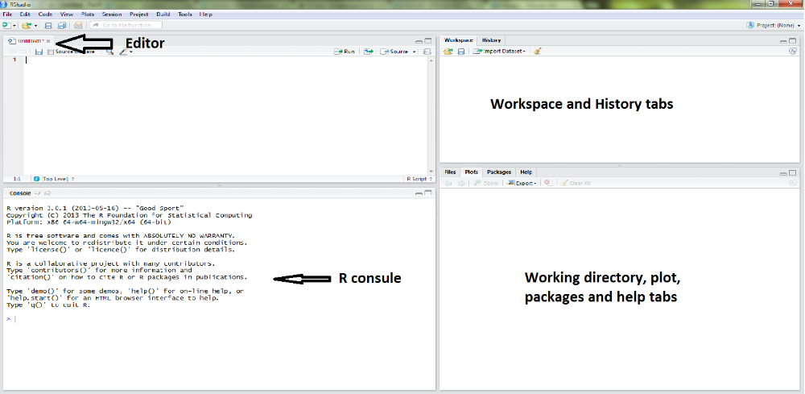
Figure 1. RStudio Environment
Find and open RStudio from Software hub or download and open it onto your own computer. Let us start by simple commands.
- Getting help: Commands in R take the form of functions; we will discuss this idea in more detail later. An example of a function is mean. To obtain help on any function, use “?name of the function". Type the following in Editor part in RStudio and press Run:
?mean
#(press Enter if you type it in Console)
Note that # indicates a comment line, that you do not need to type.
- Basic Arithmetic: R can be used as a basic (or advanced) calculator. It has a large variety of built-in functions. If you enter an arithmetic expression R gives you the results on-screen (in Console). Try the following, entering each at the prompt > in the Console.
2+2
## [1] 4
exp(-2)
## [1] 0.1353353
- Assignments: Usually, you will want to store results or allocate a value to a variable to be used many times. The assignment symbol is <-. This requires two key-strokes. Try the following, entering each at the > prompt in the Console.
x<- 2
x
## [1] 2
x+x
## [1] 4
exp(-x)
## [1] 0.1353353
Note that assignment does not produce a result; you need to have it displayed explicitly.
- Vector arithmetic: When dealing with data we normally have a set of values for one or more variables, and we want to operate on the whole variable, not a single value. For example, we may have recorded height, weight and sex of 6 students. We have three variables and each variables contains 6. Here is an example from Dalgaard.
weight<- c(60,72,57,90,95,72)
weight
## [1] 60 72 57 90 95 72
height<- c(1.75,1.80,1.65,1.90,1.74,1.91)
height
## [1] 1.75 1.80 1.65 1.90 1.74 1.91
bmi<- weight/height^2
bmi
## [1] 19.59184 22.22222 20.93664 24.93075 31.37799 19.73630
- Plotting: A picture is worth a thousand words! Not always, but visualising data is an important part of understanding what is shows. Try the following.
plot(height, weight)
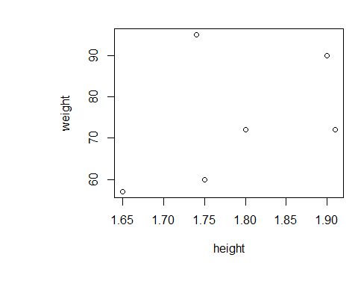
Figure 2. An illustration of a simple x-y scatter plot. In this example the x-axis are heights, and the y-axis are weights.
You should get a simple x-y plot (scatter plot). Note which way around the variables are and how this is reflected in the order in which you entered them in plot function. Try to interpret the plot in Figure 2 and discuss with others.
Further Exercises
- For a comprehensive understanding of R, refer to “Introduction to R – Workshop” located in course resources. There are further examples and some additional important R tools (e.g. creating a function etc).

